Saturday, March 25, 2017

Family & Friends Hike Report

It was a great day for our “Family & Friends Hike” in the Brandon Hills on Saturday! Cheryl & Kevin met us at 10 a.m. in the Parking Lot at the Hills, along with their kids Dathan (14) & Kyler (10?), and dog Ariat. Arthur & Shirley also joined Rick & Sue, who had grandkids Kiera (12), Caeli (11), Liam (9), & Brinn (7) in tow.

We hiked Loop B, then stopped at the warming cabin to build an outdoor fire where we roasted wieners, bean burgers & made s’mores. We then hiked back to our vehicles, concluding our event at about 12:30. Step count: 9,800 according to the Fitbit J

We could sense that winter’s grip is finally letting go, & it was nice seeing water flowing under the ice. It was a most enjoyable start to the weekend, and new friendships were forged.

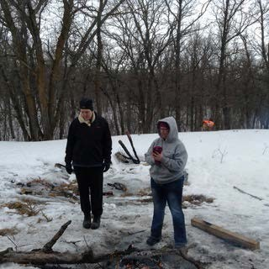

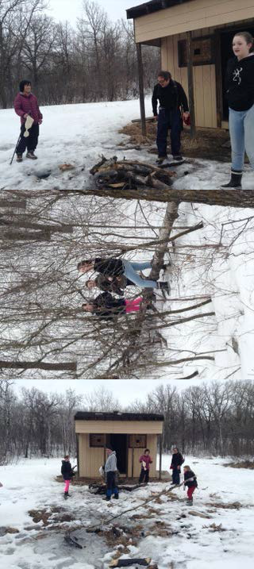

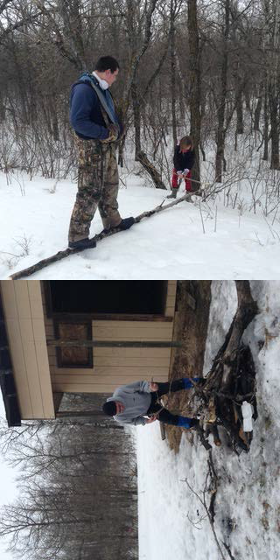

Sue Palmer

